Wellness Forever Clone
Using MERN
[A Mini E-Commerce Pharmacy Platform]

Submitted By
Name: Divya Pansare

INDEX
Sr. No | Section
1 | Introduction
2 | Project Overview
3 | Technologies Used
4 | Features Implemented
4.1 | Home Page & Navigation Bar
4.2 | Product Display
4.3 | Add to Cart Functionality
4.4 | Receipt Generation & Download
4.5 | Attractive UI with Bootstrap & CSS
4.6 | Footer Section
5 | Future Enhancements
6 | Screenshots & Visuals
7 | Conclusion

Introduction
The Wellness Forever Clone is a MERN application designed to replicate the core functionalities of an online pharmacy. This project serves as a mini e-commerce platform, allowing users to browse a selection of products, add them to the cart, and generate a receipt upon checkout. It is developed using HTML, CSS, JavaScript ,MERN ensuring an interactive and user-friendly experience. This project demonstrates essential e-commerce functionalities and provides a foundation for further enhancements.

Project Overview
The Wellness Forever Clone is a MERN application designed to replicate the features and functionalities of the popular pharmacy and wellness e-commerce platform Wellness Forever. This project aims to provide an online pharmacy experience where users can browse, search, and purchase medicines, healthcare products, and wellness items.

Technologies Used
- MERN
- HTML
- CSS
- JavaScript
- Bootstrap

Features Implemented
- Home Page & Navigation Bar
  - A well-structured home page with a clean UI
  - Effective navigation bar with smooth scrolling and easy access to different sections
  - Carousel integration for highlighting featured products or promotional content

- Product Display
  - Limited set of 6 products showcased
  - Use of Bootstrap cards for an attractive product layout
  - Product details including name, price, and image

- Add to Cart Functionality
  - Users can add products to the cart effortlessly
  - Cart dynamically updates with selected items, quantity, and total price calculation
  - Smooth UI interactions for a better user experience

- Receipt Generation & Download
  - After checkout, a receipt is generated dynamically
  - Users can download the receipt for future reference
  - Well-structured receipt format including product details, total amount, and order summary

- User Authentication & Backend Integration
- Secure user authentication with JWT and bcrypt for password hashing
- Users can register, log in, and maintain session state using authentication tokens
- Personalized shopping experience with saved cart items in the database
- Role-based authentication (Admin and User) for managing product listings

- Attractive UI with Bootstrap & CSS
  - Responsive design ensuring smooth adaptability across devices
  - Bootstrap components for a modern and interactive experience
  - Use of custom CSS styles to enhance the visual appeal

- Footer Section
  - A well-structured footer providing additional links and contact details
  - Social media icons for improved connectivity
  - Ensures a professional and complete look to the website

Future Enhancements
- Expanding the product catalog.
- Implementing user authentication for personalized shopping experience.
- Integrating payment gateway for a complete e-commerce solution.
- Adding more interactive elements, such as product filtering and sorting.

Screenshots & Visuals
Home Page:

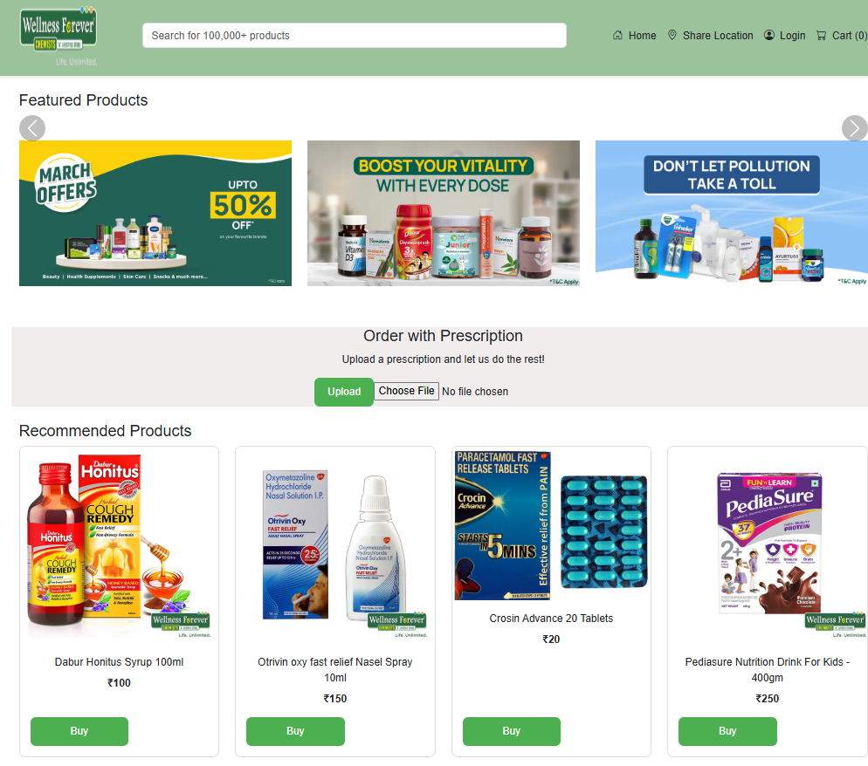

Login :

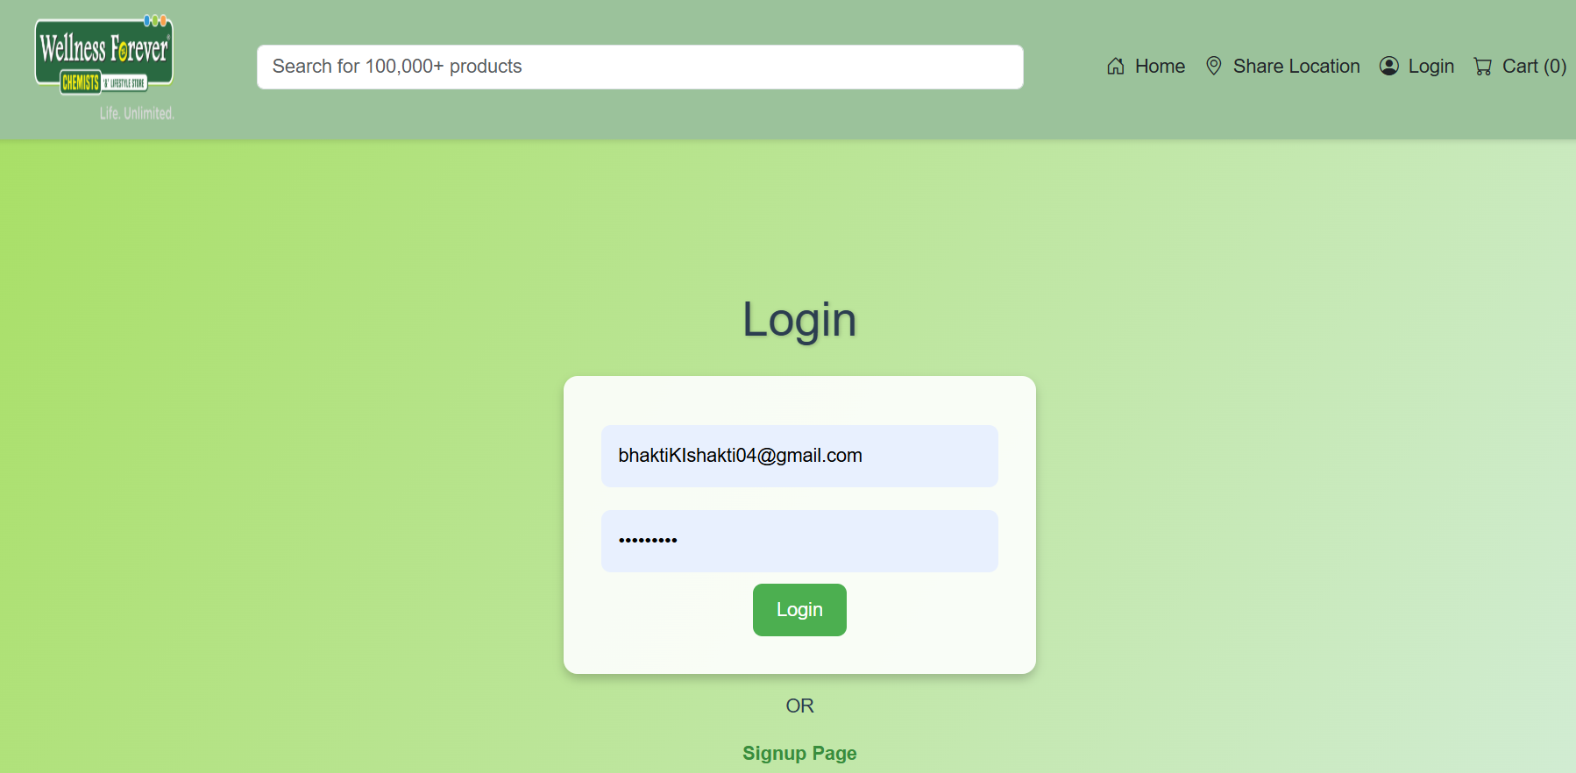

Footer:



Cart:
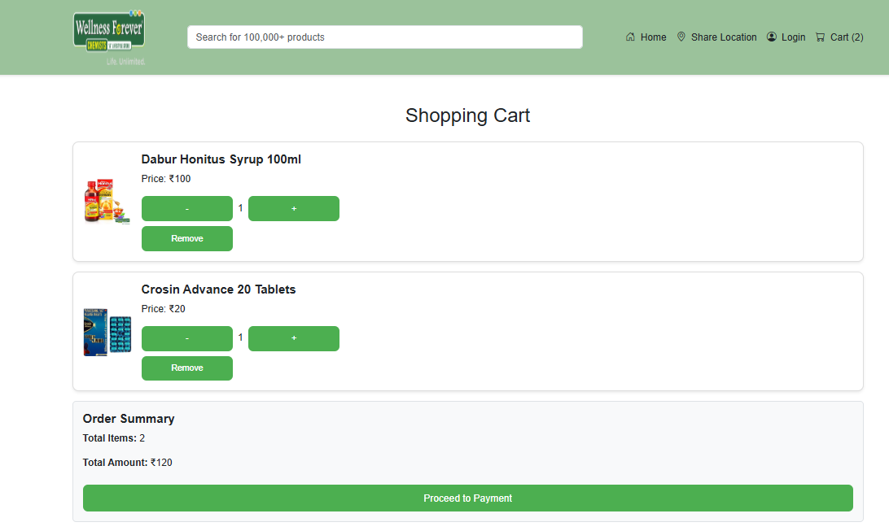
Payment QR code :

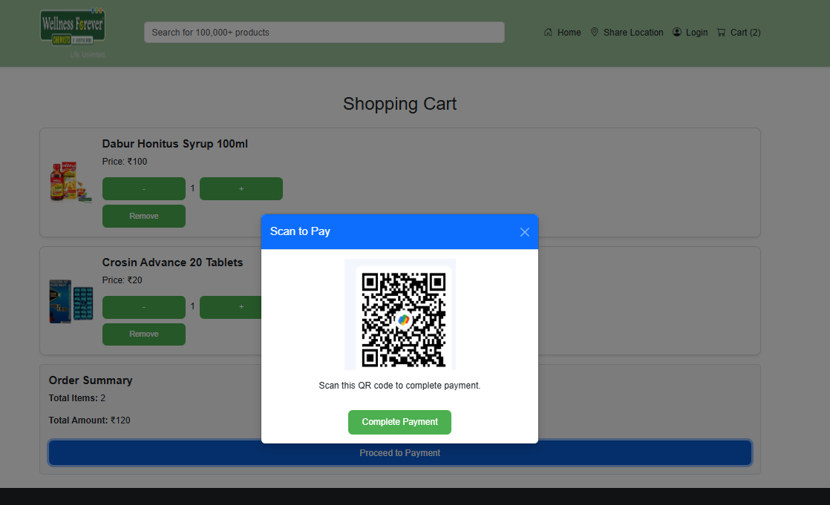
Order Completion :

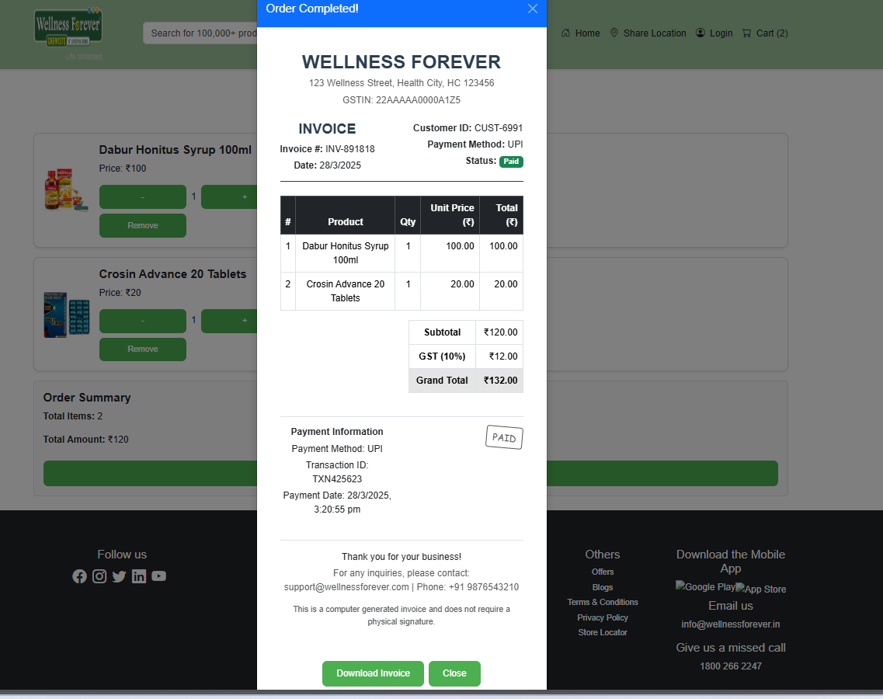

Database :

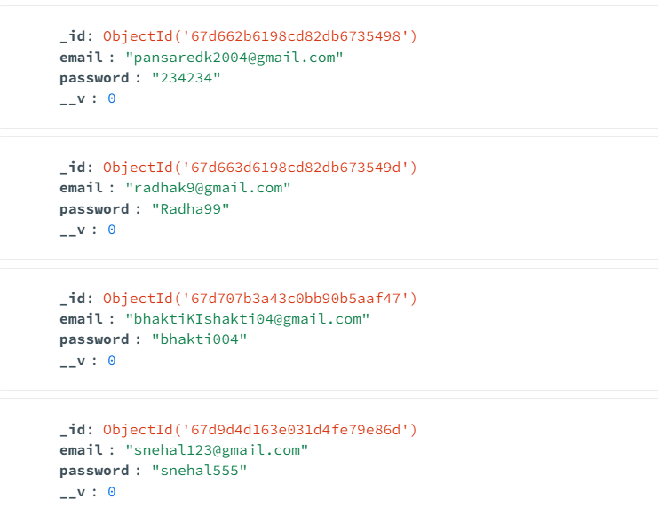

Invoice :
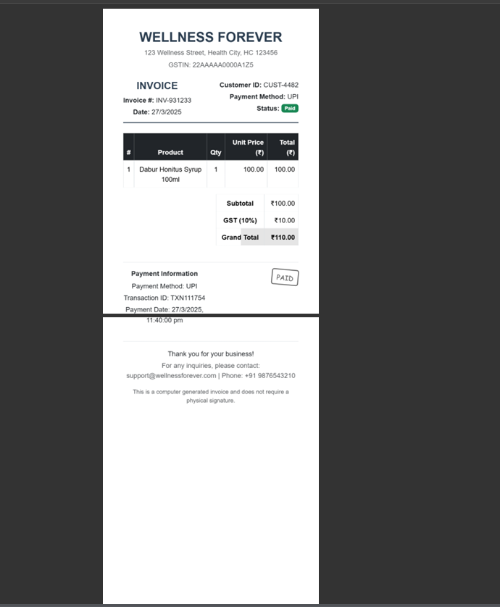

Conclusion :
The Wellness Forever Clone successfully replicates the core functionalities of an online pharmacy platform. The transition to React and backend integration has significantly improved performance, security, and scalability. This project provides hands-on experience in React, Node.js, Express, MongoDB, and authentication techniques, making it a strong foundation for building full-fledged e-commerce applications in the future. With potential enhancements like payment gateway integration, advanced filtering, and an admin panel, this project has great scope for further development and deployment.

